A Collector’s Guide to the Thoth Tarot
Shellay Lynne Maughan 2015

The Book of Thoth
The Thoth Tarot was designed by Aleister Crowley and executed by Lady Freida Harris. The project took five years, from 1938 to 1943, and was published as The Book of Thoth [h]. What we now know as the Thoth Tarot are the illustrations for this book. This major undertaking was completed near the end of Crowley’s life and reflects his seasoned thinking and accumulated knowledge.
The collaboration between Crowley and Freida Harris was an active one [i]. A major feature of the illustrations is the use of Projective Synthetic Geometry, or magical perspective, that Harris explored constantly in her artwork.
There was no deck of cards printed to accompany the Book of Thoth, but it’s clear that Crowley intended there to be one as soon as time and funds allowed. As it turned out this was not until the late 1960s, after both he and Freida Harris had passed on. Since its first publication as a color deck, the Thoth Tarot has never gone completely out of print, a claim that can be made by almost no other tarot deck.
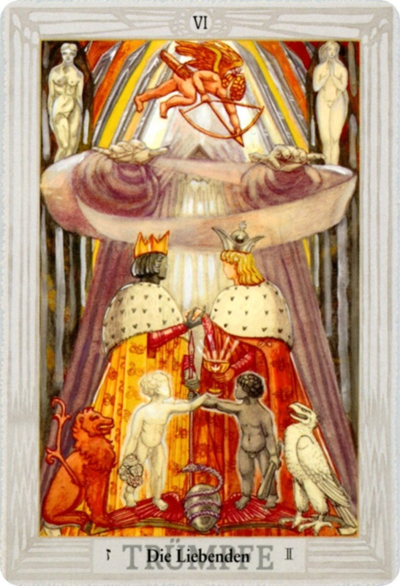 |  |  |  |  | Sangreal One-Color Thoth  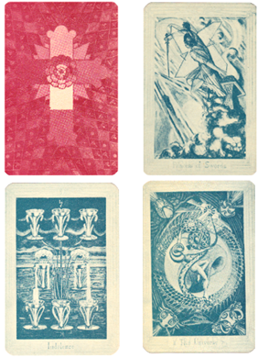  Sometime in the mid to late-1960s Carr Collins and the Sangreal Foundation commissioned the Simpson Printing Company of Dallas, Texas to print the B&W illustrations from a first edition of The Book of Thoth [b], as a tarot deck. The images were printed with blue ink, and the backs in red. The size of these cards was 5.5 x 3.75 (140 x 95 mm), which became the de facto standard for all large size Thoth decks. About 250 decks were made.  Lt Ed. OOP
An article in "Magical Blend" refers to another deck tinted in green and published by Shambhala, in 1968. This is probably the same deck with some confusion over the publishers, but that’s just my speculation. I haven’t been able to find a complete copy of the article. (Eboni Anpu; Lotte Lieb & Bill Heindrick: Talking Tarot [Magical Blend])

First Edition in Color
In the late 1960s Llee Heflin [f] traveled to England to photograph Lady Frieda Harris’s original watercolors, then still in the personal possession of Gerald Yorke. Under Hymenaeus Alpha, the cards were published in color for the first time in 1969, from these photos. They were produced in a large, 5.5 x 3.75 inch format, and housed in a high quality two piece ‘slider’ box; a gold inner box which holds the cards and a white outer box that slides over it. With a traditional flair, the box printing was done in red and black; black text and a red O.T.O. lamen. The back was the Rose Cross in full color. There was no Little White Book (LWB), but each deck included a contact card with an introductory message and contact information for those interested in learning more about the Order. All editions thus Out Of Print (OOP).
There is disagreement, even among experts with access to all records, as to which ‘White Box’ was published first and is the First Color Edition. I lean toward the conclusion that Weiser is the first edition, based on the lack of errors in the Weiser deck (suggesting access to the actual photos), the synchronicity of the printing dates with the printing of The Book of Thoth Weiser edition, and the fact that Llewellyn doesn’t clearly claim to have published the early edition. That said, no less an authority than Hymenaeus Beta himself disagrees with my timeline and states that the Llewellyn came first.
Please Note: Hymenaeus Beta generously gave comments; this should not be taken to mean that he endorses the accuracy of the information herein.

Weiser White Box A 1969(?)
"Distributed by Samuel Weiser, 734 Broadway, N.Y. 10003; Printed in U.S.A."
Unornamented borders on the card faces, no Hebrew letters or other symbols. The hue of the card borders is not consistent throughout the deck. Majors are numbered with Roman numeral at top of cards, minors with Arabic numerals. Rose Cross covers the entire back of the card. The Caliph Card has the PO Box number as "2043". Stuart Kaplan gives the publication year as 1969 in his Encyclopedia of Tarot, vol. III.

Llewellyn White Box B 1972
Llewellyn’s history site shows “Edition by Llewellyn in cooperation with O.T.O. 1971-72” and, separately, a picture of the box tagged 1/1/1972 [c].
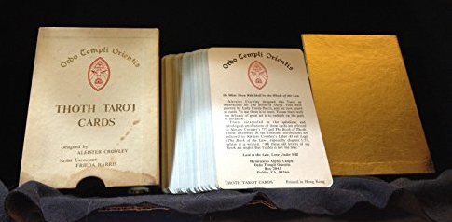
Printed in Hong Kong.

Lewellyn-Weiser Edition White Box B 1973
Printed in U.S.A. published with the collaboration of Grady McMurtry, Lee Heflin, and Gerald Yorke.
Unornamented borders on the card faces, no Hebrew letters or other symbols. Majors numbered with Roman numeral, minors with Arabic numerals. Rose Cross back.
Nearly identical to the Weiser edition, however there were (at least) two misprints in both the Hong Kong and early U.S. printings of the Llewellyn edition that do not appear in the Weiser:
- The number "8" is missing from the top of the "8 of Cups" card.
- The illustration for the "Ace of Pentacles" card is printed upside-down.
Later printings of the Lewellyn-Weiser Edition corrected these defects. Early printings give the PO Box number as "2043", in later printings it was changed to "1111."

First Reissue
In 1977, due to the efforts of Gerald Yorke and Stephen Skinner, the original artwork was re-photographed and higher quality images became available. [d] The deck was reissued with a number of changes:
The box became a standard card-box with top flap opening, white with printing in black and red and a red O.T.O. lamen. The back of the box was still the Rose Cross, but ‘ghosted’ and overlaid with text. The geometric border featured on the original art was included on the card faces for the first time, together with the Hebrew letters and alchemical or astrological attributions next to the titles of the Trumps. A LWB was added, with text “by James Wasserman, plus essay written by Lady Frieda Harris with commentary and footnotes by Stuart R Kaplan”, this became a standard feature. (Note: When looking at a specific deck, don’t confuse the card publication dates with the LWB publication dates.) The cards remained large format (5.5 x 3.75) and the O.T.O. contact card with address was included. There were several slightly different editions of this version, all OOP.
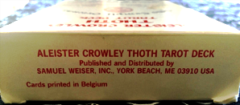  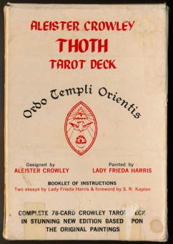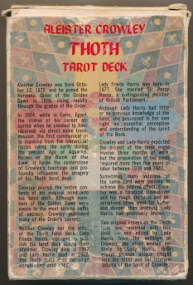 |  |  | Weiser  White Box C 1978  Samuel Weiser Inc. in co-operation with US Games Systems Inc.  Printed in Belgium by Carta Mundi.  A booklet accompanies the deck stating copyright 1978 by Stuart R. Kaplan and Donald Weiser.

Llewellyn
Date unknown. Publication information on the top of the box reads "Distributed by Llewellyn Publications, P.O. Box 43383, St. Paul, MN 55164. Cards printed in Belgium. Booklet and box printed in USA."

Weiser
1983
Samuel Weiser Inc. in co-operation with US Games Systems Inc.
In 1983 an ISBN-number was added: ISBN 0-87728-452-0

U.S. Games Systems Variation
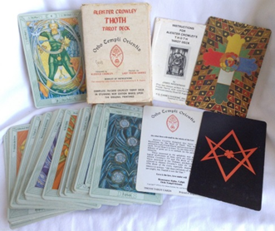 |  |  |  | U.S. Games Systems  1986  Printed in Belgium by Carta Mundi. This version has significant changes:  - The front of the box is the same as the previous ‘White box C’ editions, but the Universe card is now on the back, with no text.  - Weiser's name does not appear on the box, which only states "Published and distributed by US Games". The contact card becomes an introduction card; the message is still there but no address is included.  - There is an additional black card with a red unicursal hexagram.
Early printings of this version are often referred to as the "Green Thoth," due to the significant green tint to the card borders, and general greenish cast to the images. This was corrected in later printings. A three language edition and a four-language edition of this variation were also published:
- In the three-language edition, English titles appear at the center bottom, French and Spanish titles near the upper corners of the border.
- The four-language edition is the same as the three-language edition, with the addition of German titles.

AGMüller and U.S. Games Systems
In 1986 the paintings were again re-photographed. The deck was printed by AGMüller, Switzerland. The Rose Cross back pattern was now surrounded by a white border on which the copyright notice was printed; this became the standard. Two extra Magus cards were added to some decks, reproduced from Frieda Harris' drafts. The earlier Roman numerals on the Trumps were replaced by Arabic numbers, and a ‘1’ was added to the aces. The deck became available in different sizes. Except as noted, there is no unicursal hexagram card and no introduction/contact card, the inside last page of the LWB has text with a much shorter O.T.O. greeting and an invitation to that those interested in contacting the order that they write to Ordo Templi Orientis care of US Games.
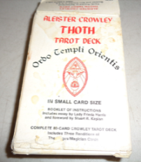 |  | AGMüller and U.S. Games Systems  1986  Booklet has: Copyright 1978, 1983 1987 by Stuart R. Kaplan & Donald Weiser.  The white box is similar to the white US Games/Weiser, with “In Small Card Size” under the lamen. On thebox : "Published and distributed by US Games Systems Inc and AGMüller & Cie, Switzerland. Includes three Magus cards.  OOP
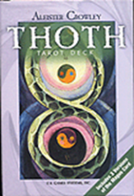 |  | AGMüller / Urania GMBH  1986  Distributed by Urania GMBH, Germany (then the publishing arm of AGMüller)  ISBN: 0-88079-308-2 Box & LWB  Banner across lower right corner: "New Edition".  Cards measure 4.75" x 3.375". "Copyright by AGMüller 1986" is printed on all cards as well as the box.
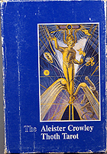 |  | AGMüller  1986  ‘Large Swiss Blue Box A’ (early edition), Publication information on the box reads “© 1986 by AGMüller, CH-Neuhaussen”  Cards measure 3.75" x 5.5" (9.5 cm x 14 cm)  Standard card-box, showing the Magus card, left-aligned, surrounded by a blue border. The deck title appears below the illustration. This edition contained the three different renditions of the "Magus" card. OOP
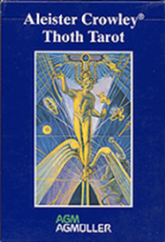 |  | AGMüller  1996  ‘Large Swiss Blue Box B’ (later edition), Publication information on the box reads "© 1944, 1962 OTO International/AGM, Switzerland."  ISBN: 0-88079-469-0 Box, 3-905021-60-9 LWB  Cards measure 3.75" x 5.5" (9.5 cm x 14 cm)  Standard card-box, showing the Magus card, centered and surrounded by a blue border. The deck title appears above the illustration, and the publisher's name appears below.  There is an OTO card included with this edition (details uncertain), and a rainbow Unicursal Hexagram card. One magus. LWB with alternate contents: 41 pages, by "the Hermit"; an excerpt from Aleister Crowley's original Book of Thoth. This booklet is different from the US Games' versions. There is no mention of US Games, Kaplan nor Weiser. OOP
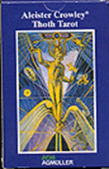 |  | AGMüller  1997  "Pocket Swiss Blue Box" Published by AGMüller and distributed by U. S. Games Systems, Inc. Printed in: Switzerland  ISBN: 3-905219-06-9 Box & LWB  Cards measure 2.25" x 3.5"  Standard card-box, showing the Magus card, centered and surrounded by a blue border. The deck title appears above the illustration, and the publisher's name appears below. Box reads:"© 1944, 1962 International OTO / AGM, Switzerland."  There is an OTO card included with this edition (details uncertain), and a rainbow Unicursal Hexagram card. One magus. LWB with alternate contents: 43 pages, A Descriptive Essay by Aleister Crowley, edited by Frieda Harris with a foreword by Hymenaeus Beta. As above, there is no mention of US Games, Kaplan nor Weiser.
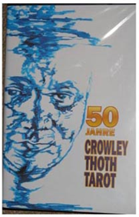 |  | Urania Verlag  Switzerland 1994, Limited edition of 1994 sets.  Aleister Crowley Thoth Tarot Jubiläums-Set.  For the 50 year anniversary of the original publication of The Book of Thoth, Urania Verlag issued a limited and numbered edition which contains the deck, the German translation of The Book of Thoth, a poster depicting the "Eight of Wands" and a CD with recordings of rituals, calls and poems performed by Crowley. Lt Ed, availability unknown.

U.S. Games Systems
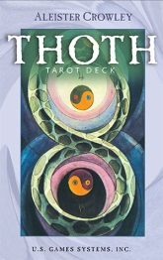 | U.S. Games Systems  Crowley Thoth Tarot Deck Small, 1996  Deck printed in Belgium; U.S. GAMES SYSTEMS, INC.; Stamford, CT 06902 USA.  Card size 2-7/8" x 4-3/8"  Booklet: "copyright 1978, 1983, 1987."  This deck no longer features the 2 extra Magus cards. Still in print 2015
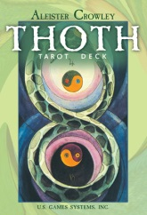 | U.S. Games Systems  Crowley Thoth Tarot Deck Large, After 1986  978-0-913866-15-3  Deck printed in Belgium; U.S. GAMES SYSTEMS, INC.; Stamford, CT 06902 USA.  Cards measure 3-3/4" x 5-1/2  This is the only English version in print that includes the extra magus cards. Still in print 2015
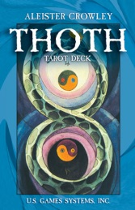 | U.S. Games Systems  Pocket Swiss Crowley Thoth Tarot Deck, 2000  978-1-57281-294-9  Cards measure 2-1/4" x 3-1/2"inches, Standard poker deck size.  Still in print 2015
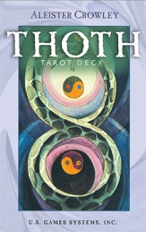 | U.S. Games Systems  Crowley Thoth Tarot Deck -- Premier Edition, December 31, 2005  ISBN: 978-1-57281-510-0  Cards measure 2-7/8" x 4-3/8"  Includes a LWB and a ten-card spread sheet. This deck no longer features the 2 extra Magus cards. Still in print 2015.
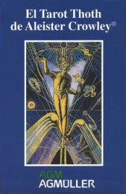 | U.S. Games Systems and A.G. Müller  Spanish Crowley Thoth Tarot Deck Small  ISBN 978-1-57281-168-3  Size 2-7/8" x 4-3/8"  Still in print 2015.

Urania Verlag
The Golden Thoth
2008
LWB, 152 pages with a foreword by Hymenaeus Beta, two previously unpublished essays by Lady Frieda Harris, and excerpts from Crowley’s writings.
Printed using new photographs of the original art, with care was taken to match the original painting both in hue and saturation. The borders on the card backs are gold. This excerpt is from the O.T.O. international site:
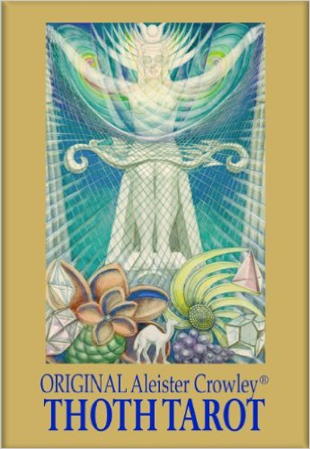
“…Around 2007, O.T.O. went to considerable trouble and expense—with very supportive assistance from AGMüller and the Yorke Collection curators—to digitally re-photograph the deck in high resolution, using a (rented!) $100,000 Phase One camera. We even did the typesetting and layout for the new deck in multiple languages, including English, for free—all in the interests of finally getting a version out that would meet Crowley’s and Lady Harris’ exacting standards. We’ve been very disappointed—thus far, it has only appeared in German.
I have compared this printing of the deck to the original paintings, and it is almost perfect. The original paintings have not faded over time, as some have claimed (the originals have always been protected from light, barring brief exhibitions, and are stable Winsor and Newton pigments). The problem is that prior printings have been simply negligent about color correction—which was admittedly harder in the pre-digital era—and in some cases, colors have been “pushed” to get an effect the publisher likes. Matching the subtlety of the paintings themselves is much harder, but clearly worthwhile.” [e]
Only released in Germany, still available 2015. http://www.amazon.de/gp/product/386826504X?keywords=aleister%20crowley%20thoth%20tarot&qid=1441309081&ref_=sr_1_5&sr=8-5
 Fini 

b) Possibly #105, based on http://www.tarotassociation.net/magazine/ R. Leo Gillis p. 39, although uncertain as this article has several factual errors.
c) http://www.llewellyn.com/about/event.php?id=230
d) Lon Milo DuQuette Understanding Aleister Crowley's Thoth Tarot, p. 17
e) Hymenaeus Beta http://oto.org/news0413.html
f) Taken from http://777lleeheflin.org/939393/index2.html Llee Heflin’s on-line biography, URL now defunct
g) http://www.thelemapedia.org/index.php/Thoth_Tarot
(h) The Book of Thoth: A Short Essay on the Tarot of the Egyptians [the title of] The Equinox, volume III, number 5, Aleister Crowley, The OTO/Chiswick Press Ltd, 1944.
(i) http://www.tarokki.fi/tarotpuu/2011/03/18/lecture-on-the-tarot-by-frieda-lady-harris-sesame-club-1942/
General - with thanks to Stuart Kaplan The Encyclopedia of Tarot, vol. III

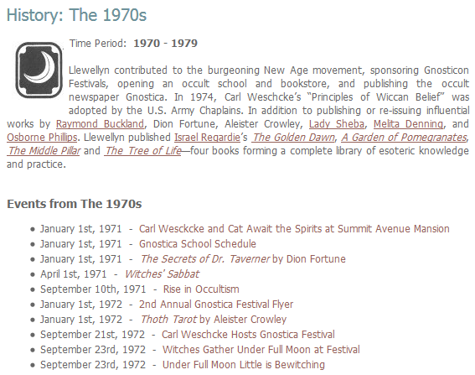
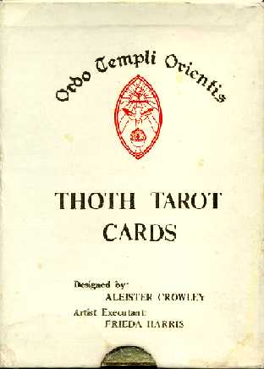

From a sale listing on the Weiser Antiquarian Books site, 2019:
CROWLEY, Aleister and Frieda Harris.

Aleister Crowley Thoth Tarot Deck. First Color Printing. [ Tarot Cards ].
St Paul, Minn. Llewellyn Publishing, ND [1972]. First Edition. 78 tarot cards + "caliph card." Card size 5 1/2" x 3 3/4". Original printed outer slipcase with thumb-notches, cardboard inner box with gilt metallic finish covering. A first printing of the Llewellyn edition of the Thoth Tarot deck, the first ever colour printing of the full Thoth deck. It was published with the collaboration of Grady McMurtry (then Caliph of the O.T.O), Lee Heflin, and Gerald Yorke. Prior to that Crowley and Harris had printed seven color test cards in 1943, and Simpson Printers had published a single-color edition (known as the "Sangreal One Color Tarot") in 1968. Known within tarot collecting circles as "White Box A" this deck is sometimes said to have been printed in 1969, whereas in fact it did not appear until 1972. The cards of the deck are distinguishable by two errors: the "Eight of Cups" is lacking the numeral that is normally stamped in the upper margin, and the image on the "Ace of Disks" is printed upside down. Unlike later printings this edition was not accompanied by an explanatory booklet although it does have a separate card with a short explanatory text, and the contact details for Hymenaeus Alpha - Grady L. McMurtry - "the Caliph card." The tarot cards themselves are about Fine condition, the "Caliph card" has a light smudge in the printer's ink in the address lines. In a VG + example of the original two-piece printed box: the box is lightly rubbed and a little darkened but cards and box are in much better condition than normally encountered (the boxes are often heavily rubbed and splitting). Thanks to R. Leo Gillis for his help with this listing. Item #51600

From James Wasserman

Producing the Thoth Tarot
A Talk at Catland Books in Brooklyn, September 23, 2017
(Image on left is a sample of the 1971 printing. Image on the right is from the 1977 photography in a German language deck)
I was originally introduced to the Tarot in 1967. I used Waite’s book and his deck. I followed his layout suggestions and was spooked by not only how accurate my first reading for myself was, but also by the fact that the Tarot pulled no punches in describing certain personal characteristics that I did not find pleasant.
The Tarot became extremely important to me when I read Paul Foster Case’s superb book Tarot: A Key to the Wisdom of the Ages. He uses the cards as an introduction to Qabalah and the Tree of Life—which link all known themes of the metaphysical world such as astrology, mythology, magick, and alchemy.
In 1969, Weiser’s published The Book of Thoth, Crowley’s magnum opus on the Tarot. This was a well-executed second edition, a reprint of the 1944 original. Crowley’s own publication was an exquisitely printed, limited, numbered, and signed edition of 200 copies that has been a treasured collector’s edition since. Its eight color plates of several cards were hand-pasted in.
O.T.O. Caliph Grady McMurtry helped Crowley finance the printing of that first edition and was given a part ownership of the rights in return.
I bought my hardcover copy of the 1969 Weiser second edition the day it was placed on sale at the bookstore at 734 Broadway. I lived at the time about 100 miles away in New Jersey. I awoke from a dream in which I was told Crowley’s Tarot book was at the store. I drove up, walked in, asked about it, and was met with a smile by the clerk.
That copy traveled back and forth across the country with me for years in my 1956 International Harvester van — fitted with bed, stove, 8-track tape player, and bookcase. When I landed for my three decades in New York City, it seemed I changed apartments as often as some do their socks! And each time, I packed my copy as carefully as I could. But it endured a lot of wear and tear from both moving and reading. It’s so good to have this new 60th Anniversary Weiser Books hardcover! More on that in a bit.
In 1971, the first printing of the Thoth Tarot cards was published. It was much welcomed by all Tarot devotees and Crowley aficionados, but it was a muddy-looking deck of disappointing print quality.
The paintings at the Warburg Institute in London were photographed for that 1971 printing as 35 mm slides by Llee Heflin of Level Press. He worked with Grady McMurtry who arranged for Heflin to gain access to the paintings. Weiser and Llewelyn published the decks, and were soon joined by playing card specialists US Games.
I began working at Weiser Bookstore in 1973 and moved into the publishing department about 6 months later.
Donald Weiser and I became close. I eventually discussed with him how inferior the cards of the deck were when compared to the quality of the beautiful images in The Book of Thoth itself. I knew the deck could be improved.
It had sold so well that I was able to persuade him to give me permission to discuss making new photographs of the paintings at the Warburg Institute. I entered into correspondence with Gerald Yorke who controlled Frieda Lady Harris’ portion of rights to the Tarot paintings. He referred me to the Director of the Warburg, at the time Dr. J. B. Trapp. Yorke had donated the paintings to the Warburg for safekeeping.
Donald then introduced me to Stephen Skinner, a friend of his, a fellow occultist, writer, and small publisher. Together Stephen and I worked to hire a local British photographer to shoot the cards in 4 x 5 format.
Our photos were thus about 400% larger than Llee Heflin’s 35mm photos. They were almost the same size as the cards we printed. In color printing, the key is to make photos at least as close to the size of the printed product as possible. Photos can certainly be larger and then reduced, but never successfully enlarged without some degradation of image quality. Thus, the second edition of the Thoth Tarot in 1977 was actually the first professionally produced publication of the cards.
I spent about two years in the process of negotiation and production of the new decks. As the project was entering its final stage, I left Weiser in the late spring of 1977 to start Studio 31. Everything was set and going well. I was confident the decks would be fine. I remained in close contact with Donald and Stuart Kaplan of US Games who were co-publishing the new deck.
They commissioned me to write the booklet to accompany the cards. I can’t imagine how many are in print at this day, but I received $250 for my work. I wrote a brief introduction about Tarot, Crowley, and Lady Harris, and carefully compiled the divinatory meanings of the cards from The Book of Thoth and the Golden Dawn materials. I got Robert Wang’s permission to adapt a 15-card layout he had given in his book, An Introduction to the Golden Dawn Tarot, which he had naturally adapted from someone else. I modified it slightly based on my experience. Bill Breeze helped by giving me a catalog of an exhibit of Lady Harris’ paintings written by Robert Cecil. He also found another exhibit catalog with a short introduction by Crowley. So with all that material, the pamphlet was and is a well-done guide to the deck.
About three months after leaving Weiser, I was informed that the first proofs were finally in. I eagerly went into the office to see them.
Because the paintings have a slight variance in size, and the images need to be perfectly standardized for printing, we needed to make a common border for each card. Then the specific card name and number were printed on each border. The 1971 printing had a plain border. We, of course, used Crowley’s border design—standardized across the 78 images.
Crowley and Lady Harris had used a gray border. The printer proofs offered us a choice between the Crowley gray and an awful baby blue the printer had suggested as an alternate. I pointed out the obvious—that the blue border was unacceptable.
I was mortified to learn that “everyone” in both Weiser and US Games “loved” the baby blue-colored border better. I begged them not to go with this option but it was like talking to the wall.
I had a sense that one reason for my predicament—at least as far as the person who had replaced me at Weiser was concerned—was a resentment at my having left. Here was an opportunity to say, “Now I’m in charge and, guess what: there is nothing you can do about it.”
I called Stuart Kaplan of US Games and asked to set an appointment for the next day to discuss my concerns.
I was acutely aware of how powerless I was after so much work. I understood I didn’t have a leg to stand on as an ex-employee—but that the proper production of the deck was my karmic task.
I have always been concerned about the improper use of Magick. Crowley writes that any magick that is not an invocation of the Holy Guardian Angel is black magick.
But in this situation, non-initiates who were less aware were making a power play that would damage the spiritual impact of the deck by changing the vision of its original designers to something they “liked better”—while gleefully taking advantage of the chance to needle me about having abandoned ship. It was a case in which I felt I had no choice but to perform magick to right the situation.
It worked, but in an interesting and dramatic sequence. I knew Stuart Kaplan to be a diligent researcher into Tarot. I went to his office to try to convince him to use the gray border. My arguments fell flat. I left, despondent, thinking the magick had failed and unable to understand why and what I did wrong.
On the street, I experienced a sudden illumination. I became aware of an argument that would appeal to Stuart’s best instincts. I called him from a pay phone twenty minutes after leaving our meeting and somewhat breathlessly explained the Qabalistic significance of the border colors, and why blue would violate the psychic energies that the color gray would stimulate. Gray, in the Queen Scale, is the color of Chokmah, the Sphere of Wisdom. It is therefore associated with Tahuti, the Egyptian name of Thoth, the God of Wisdom. Crowley’s choice was no accident.
Stuart immediately accepted my reasoning and ordered the proper gray borders restored! When I walked into the Weiser office later that day, my former assistant, was shaking her head. She didn’t understand how a dozen people had chosen the blue and it was being returned to Crowley’s gray. Donald just smiled.
In his essay “The Revival of Magick,” Crowley writes: “What the Magician calls God is merely the divine Emanation in himself. … it follows that unless the will of the magician be really at one with the Will of the Cosmos, this likeness does not exist, this identification does not take place. Therefore the Magician cannot really perform any miracle unless that be already the Design of the Universe. So that he who sets out by saying, ‘I will impose my will on all things’ ends ‘Thy will be done.’”
Since our second set of photographs forty years ago, there has since been a third set of photos of the paintings made by O.T.O., meticulously color-corrected against the original paintings. Until now, only one deck with these images has been printed—in Germany in 2008—but we expect these images will one day become the standard. The differences between the new images and the 1977 images are not nearly as dramatic as those between the 1971 and 1977 printings. I’ve brought samples of each of the three decks for you to compare.
I am also happy to let you know that some years ago, O.T.O. arranged to archivally preserve the original Tarot paintings at the Warburg for future generations to come.
The more recent O.T.O. photographs are featured in this brand new edition of The Book of Thoth from Weiser Books. We have again a high quality hardcover with even better color and black-and-white images. Weiser Books has also reproduced the beloved 1969 jacket, with more generous inside flaps and printed on better paper.
As a real treat, the book includes high quality color endpapers of the Egyptian design that was printed on the cover of Crowley’s 1944 edition. The text paper used in the book is a quality coated art paper which better highlights the color plates as well as Crowley’s halftone plates of the entire deck.
Crowley’s legacy is rich and vast. The Tarot was his great love and the deck and book are perhaps his most well-known contribution as far as the general public is concerned. Paul Foster Case discusses the famous legend that the Initiates of Antiquity from all over the world met periodically in Fez, Morocco to share the Sacred Knowledge. Because of language barriers they invented the Tarot in the year 1200 to be better able to communicate their doctrines in pictures and symbols that transcend language differences. The Tradition further states that they later disguised these Wisdom Teachings as a deck of playing cards, passing them to the Gypsies who then traveled throughout the world, telling fortunes and playing games of chance, the Sacred Secrets hidden in plain sight.
Symbols and art are the most potent means of communication as they reach directly into the Unconscious. Lady Harris called the Tarot “God’s Picture Book.” Since before the days of Ancient Egypt, art has been the favored vehicle for the communication of Truth. I am grateful for having been able to play a part in communicating Crowley and Harris’ vision to a wider audience.

Strange2
04-09-2007, 04:48
I have received "The Lovers" and "Ace of Swords" cards from the first test printing of the Thoth deck, and I must say I am thrilled. They are in very good condition. The colors are deep and vivid, particularly on the Ace of Swords.
A description from the catalogue:
http://www.weiserantiquarian.com/catalogtwenty/
"Aleister Crowley, & Frieda Harris, Two Tarot Cards - 'The Lovers' and 'The Ace of Swords,' from the 1943 test printing of the Thoth Deck. [London]: NP, circa 1943. Two 5 1/4" x 3 1/2" color-printed sample cards: one of 'The Lovers,' and one of 'The Ace of Swords.' In 1943 Crowley had a series of collotype printing blocks made to reproduce in color the images of seven individual tarot cards plus the design that he intended to have printed on the reverse side of each card. The plates were primarily struck so that high-quality color prints could be made to tip into his forthcoming The Book of Thoth, however he also took advantage of their availability to have a small test run of those cards made, for distribution to friends and acquaintances who might be persuaded to help finance the full printing of the pack. These are two of that test run. Each with the Rose Cross design on the back. Very unusual, and the true first printing of one of the most famous tarot decks."
Perhaps Crowley and/or Harris handled these 2 cards at one time!
It appears the cards may be composed of 2 pieces of high quality paper bonded together, but I'm not sure. Not as heavy as a traditional card stock.
The cards are slightly smaller than the cards found in the commercial large versions of the deck (which are 140 x 95 mm).
The Lovers: 135 x 90 mm, 5 5/16 x 3 1/2 in.
Ace of Swords: 134 x 90 mm, 5 1/4 x 3 1/2 in.
The grey frame on the Ace of Swords has an additional light grey unbroken line on the outer border, which is not found in other versions of the deck.
The back of the cards has an additional full row at the bottom of the card that does not appear in commercial versions of the deck. This row does not contain the Wand, Cup, Sword, Disk designs within each section, but just contains the colors for each section (red for Wands, blue for Cups, gold for Swords, green for disks). There is also a partial row visible at the bottom, on the right, and at the top of the card.
I find the colors on the Back design of these prototype cards to be more vivid than in commercial versions of the cards, particularly the green disk sections and the blue cup sections.
I have attached scans of the cards, front and back.
I have also posted higher resolution scans on Flickr:
http://www.flickr.com/photos/21201893@N00/sets/72157601839875788
My joy is to see your joy!
http://www.tarotforum.net/archive/index.php/t-84309.html

Original Printing Plates For The ACE OF DISKS & THE SUN
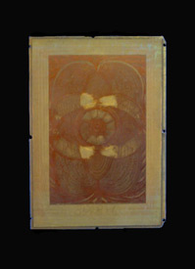
Crowley, Aleister & Frieda Harris - related material]. An original engraved printing plate, used to reproduce the colour plate of the Tarot card 'Ace of Disks' in the First edition of The Book of Thoth (1944) and the prototype samples of the Thoth Tarot cards (1943). London: OTO/Chiswick Press Ltd. [1944], 1943. The plate is metal (probably copper?) 3 3/4 x 5 1/2 inches, and is mounted on a second brass or copper sheet that is about 1/8 of an inch larger on each edge. The method used for the printing was the collotype process, which in this instance required four different printer's blocks for each illustration. These were run through the presses in sequence with different colored inks, the end result being the very high quality color reproductions that were required. The blocks within any given set varied quite dramatically in appearance. One or two would usually have sections of the background of the design cut away or deeply engraved so that there was no chance of the ink adhering to those parts of the design where it was not wanted. This gave the plates themselves a high relief, almost sculpted look. Others of the plates were lightly but very finely etched on the surface, giving them enormous detail, although it usually requires reasonably close examination of the plate to see it. In 1943 Crowley had eight sets of these printing blocks made: seven sets were for the designs for the tarot cards 'Ace of Disks', 'The Lovers,' 'The Ace of Swords,' 'The Sun,' 'The Hierophant,' 'Lust', and 'The Universe,' with the eighth set for the Rose-Cross design that would appear on the reverse side of each card. The plates were primarily struck so that color prints of the designs could be made to tip into his forthcoming 'The Book of Thoth', however he also took advantage of their availability to have a small test run of those particular tarot cards made. These he distributed to friends and acquaintances that might be persuaded to help finance the full printing of the pack. The plate is from the collection of Edward Noel Fitzgerald, (1908-1958), also known as Frater Agape, a IX degree member of the O.T.O. He had been a friend and follower of Crowley's, and remained friends with Harris after The Beast's death. The two met via Crowley, and were part of the small circle in Britain in the 1950s who continued to take an interest in his work. Harris supplied FitzGerald with a small collection of material relating to the preparation and exhibition of the Thoth tarot designs, and the publication of The Book of Thoth. Although not designed as such, the plates themselves are quite decorative. They could perhaps be mounted on a box holding tarot cards, a bookend, or simply for display in a frame. However they are displayed, there is no doubt that each plate is a unique memento of the first ever printing of one of the most significant Tarot decks ever produced, and of course of 'The Book of Thoth'.This particular engraving is moderately finely done, and presents a reverse (mirror) image of the 'Ace of Disks.' Four finger nail size rubbed patches, probably deliberately done by the printers so the ink would not adhere to those parts of the design, otherwise overall VG condition. A one-of-a-kind Crowley item. $2750

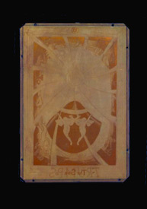
Crowley, Aleister & Frieda Harris - related material]. An original engraved printing plate, used to reproduce the colour plate of the Tarot card 'The Sun' in the First edition of The Book of Thoth (1944) and the prototype samples of the Thoth Tarot cards (1943). London: OTO/Chiswick Press Ltd. [1944], 1943. The plate is metal (probably copper?) 3 3/4 x 5 1/2 inches, and is mounted on a second brass or copper sheet that is about 1/8 of an inch larger on each edge. The method used for the printing was the collotype process, which in this instance required four different printer's blocks for each illustration. These were run through the presses in sequence with different colored inks, the end result being the very high quality color reproductions that were required. The blocks within any given set varied quite dramatically in appearance. One or two would usually have sections of the background of the design cut away or deeply engraved so that there was no chance of the ink adhering to those parts of the design where it was not wanted. This gave the plates themselves a high relief, almost sculpted look. Others of the plates were lightly but very finely etched on the surface, giving them enormous detail, although it usually requires reasonably close examination of the plate to see it. In 1943 Crowley had eight sets of these printing blocks made: seven sets were for the designs for the tarot cards 'Ace of Disks', 'The Lovers,' 'The Ace of Swords,' 'The Sun,' 'The Hierophant,' 'Lust', and 'The Universe,' with the eighth set for the Rose-Cross design that would appear on the reverse side of each card. The plates were primarily struck so that color prints of the designs could be made to tip into his forthcoming 'The Book of Thoth', however he also took advantage of their availability to have a small test run of those particular tarot cards made. These he distributed to friends and acquaintances that might be persuaded to help finance the full printing of the pack. The plate is from the collection of Edward Noel Fitzgerald, (1908-1958), also known as Frater Agape, a IX degree member of the O.T.O. He had been a friend and follower of Crowley's, and remained friends with Harris after The Beast's death. The two met via Crowley, and were part of the small circle in Britain in the 1950s who continued to take an interest in his work. Harris supplied FitzGerald with a small collection of material relating to the preparation and exhibition of the Thoth tarot designs, and the publication of The Book of Thoth. Although not designed as such, the plates themselves are quite decorative. They could perhaps be mounted on a box holding tarot cards, a bookend, or simply for display in a frame. However they are displayed, there is no doubt that each plate is a unique memento of the first ever printing of one of the most significant Tarot decks ever produced, and of course of 'The Book of Thoth'.This particular engraving is moderately finely done, and presents a reverse (mirror) image of the 'The Sun.' It does not have the great detail of the others in the set, which is particularly evident in the center or the design which is indistinct and cloudy. Overall VG condition for this one-of-a-kind Crowley item. $2750

http://www.securenet.net/tbcl/TBCL_AHOME_Crowley1.htm

https://www.weiserantiquarian.com/pages/books/55519/aleister-crowley-frieda-harris/thoth-tarot-deck-first-us-color-printed-version-llewellyn-issue-tarot-cards/?soldItem=true&fbclid=IwAR22z5WfcgAa1XA_Lggn3pfCbPtVKIrS1O2Gn1_P7rZVl59e4xWTCCts3LA Thoth Tarot Deck. ( First US Color Printed Version - Llewellyn Issue ) [ Tarot Cards ].
St Paul, MN: Llewellyn Publishing, ND [ 1973 ]. First Edition Thus. 78 tarot cards + "Calpih Card". Card size 5 1/2" x 3 3/4". Original printed outer slipcase with thumb-notches, cardboard inner box with gilt metallic finish covering and thumb notches. A Llewellyn publication of the Thoth Tarot deck (sometimes known as "White Box B") which was released in conjunction with Weiser in 1973. The Llewellyn reissue followed the first colour printing of the full Thoth deck that was done by that company in 1972 (not 1969, as is commonly but erroneously thought). It was published with the collaboration of Grady McMurtry (then Caliph of the O.T.O), Lee Heflin, and Gerald Yorke. Unlike the first Llewellyn edition, which was printed in Hong Kong, the Llewellyn / Weiser edition was printed in the USA, and is marked accordingly, and is thus the Llewellyn variant first color US printing. This particular set has the corrected versions of "Eight of Cups" and "Ace of Disks": the versions of those cards in "White Box A" and some early printings of "White Box B" carried design flaws (the "Eight of Cups" was lacking the numeral that is normally stamped in the upper margin, and the image on the "Ace of Disks" was printed upside down). Unlike later printings this edition was not accompanied by an explanatory booklet although it does have a separate card with a short explanatory text and the contact details for Hymenaeus Alpha - Grady L. McMurtry (the "Caliph Card"). The "Caliph Card" in has the PO Box number as "2043" - in later printings it was changed to "1111." The cards are used but in Very Good condition, in a VG example of the original two-piece printed box: the box is lightly rubbed and a little darkened. (Thanks to R. Leo Gillis for his help with this listing.). Item #55519

About this Item: Urania Verlag, Germany, 1987. First Edition. A large poster-sized (24" x 16.5") calendar printed in 1986 for the year 1987. 14 leaves, printed on the rectos only, and a plain card backing sheet, secured together by a spiral wire clip along the top. Magnificent large (16.5" x 10.5") reproductions of 12 different Frieda Harris tarot designs (one design - "Lust" is also used on the coversheet, so appears twice). The calendar comprises the cover sheet, followed by one leaf for each month, each with a different tarot picture, respectively from January to December: "Queen of Disks," "Six of Disks," "Ace of Cups," an alternative "The Magician," (a variant version from that in the standard deck), "Prince of Disks," "Two of Cups," "Princess of Disks," "Lust," "Knight of Disks," "Two of Disks," "The Devil," and "The Hierophant." The final leaf has an essay on the cards and their significance, "The Tarot, the Lady and the Beast" by Ralph Tegtmeier. Being so specialised and expensive to produce because of the colour printing the calendar presumably had a reasonably small print run and there is no doubt that many were taken taken apart and the individual images framed: effectively it provides 13 large frameable colour prints of the Thoth deck designs. As readers may know, most calendars are re-useable, after a certain number of years the same alignment of days and dates repeats. As it happens, this 1987 calendar will be re-useable in 2026, 2037, 2043, 2054, etc. A hint of creasing to edges, and a little curved from being rolled. Still near-fine condition. Sent rolled, in a mailing tube. Due to the small number of copies available we have to limit these to one per customer. Seller Inventory # 46161 US$ 142.00

About this Item: Llewellyn Publications, St. Paul, Minnesota; printed in Hong Kong, 1969. Cards. Condition: Good +. First Edition. First Edition. Cards. Box measures 5 3/4" X 4 1/8" X 1 1/2". 78 tarot cards, plus "Caliph Card," each measuring 5 1/2" X 3 3/4". No date of publication, generally assumed to be 1969 though several scholars date it to 1972. Printed in Hong Kong. Original, outer printed white box with thumb notches, printed in gilt and red to cover, with black lettering to sides and color illustration to rear. Golden body box. Mild edgewear to white box, with heavy foxing to all surfaces except rear of box. Moderate surface wear and edgewear to gold body box with scuffing and scratching visible in light. Moderate edgewear to tarot cards, with indentations to top and bottom left corners of all cards, small mark of soiling to "Caliph Card" at top edge, and very occasional gentle creasing to a corner. No borders to backs of cards, faces have a powder blue border with variation in color throughout, some cards paler and some darker. 8 of Cups card is missing the "8" at top of card and the pentacle on the Ace of Pentacles card is upside down, as issued and indicating early, uncorrected printing. The "Caliph Card" contains a brief explanation of the origins of the Thoth Tarot and includes the contact information for Hymenaeus Alpha (Grady L. McMurtry), this card states the P.O. Box as 2043, as called for in descriptions of original printings. Cards are in very good condition, box is in good condition, due to foxing. A highly presentable edition of Aleister Crowley's beloved, bestselling, and enduring Thoth Tarot featuring the art of Lady Frieda Harris, perhaps the rarest trade issue of the set as it is the earliest trade printing, preceding the U.S. Llewellyn and Weiser printings, with the exceedingly rare "Caliph Card" present. Seller Inventory # 4271

